Project Report Format

**REAL-TIME RIVER WATER QUALITY MONITORING AND CONTROL SYSTEM**

# INTRODUCTION :

* 1. **Project Overview :**

With growing world population and industry advancement, environmental pollution became big concern. Systems for water quality monitoring are required for activity analysis and their impact on nature of the power plants, mining sector, oil industry, etc. Basically, determination of water quality relies on estimation of values of some important and indicative parameters. For example, the water quality depends of the water temperature, activity level, water flow and presence of volatile organic compounds. Although there are well known and widely used methods for measurement of these parameters with appropriate Sensors, design of electronic systems for environmental monitoring is not often straightforward. The engineering challenges are various:(a) sensor nodes are usually deployed in remote places,(b) long-term deployments require sensor nodes to be robust and systems to be easily reconfigurable,(c) sensor nodes have to be able to operate autonomously in the required environment, etc. Moreover, such applications require highly reliable and accurate sensors with the reduced level of maintenance, long lifetime, fast response times, high sensitivity and high selectivity. With the introduction of IoT in the modern world, many problems have been solved. With the use of IoT in monitoring water quality various issues such as data collection,communication,data analysis and early warnings are worked on. But in order to get this into picture, technologies and protocols are combined to get the desired output.The IoT can be used in practically all scenarios for public services by governments. Sensor-enabled devices can help monitor the environmental impact of cities, collect details about sewers, water quality, and garbage. Such devices can also help monitor woods, rivers, lakes, and oceans. An urban IoT can provide means to monitor the quality of the water in crowded areas, parks, or fitness trails. The realization of such a service requires that water quality and pollution sensors be deployed across the city and that the sensor data be made publicly available to citizens.

# Purpose:

The objective of this system is to provide a technology-oriented, low-cost, IoT based water quality management system for people on rural and urban sides.The main objective of this system is to help people to check whether their drinking water is good to drink or not.This system is able to monitor and control water through IOT simultaneously.The flow speed of water through the pipe also can be measured.

# LITERATURE SURVEY:

* 1. **Existing problem:**

Monitoring the qualitative status of freshwaters is an important goal of the international community, as stated in the Sustainable Development Goal (SDGs) indicator 6.3.2 on good ambient water quality. Monitoring data are, however, lacking in many countries, allegedly because of capacity challenges of less-developed countries. So far, however, the relationship between human development and capacity challenges for water quality monitoring have not been analysed systematically. This hinders the implementation of fine-tuned capacity development programmes for water quality monitoring. Against this background, this study takes a global perspective in analysing the link between human development and the capacity challenges countries face in their national water quality monitoring programmes. The analysis is based on the latest data on the human development index and an international online survey amongst experts from science and practice. This negative relationship increases along the course of the monitoring process, from defining the enabling environment, choosing parameters for the collection of field data, to the analytics and analysis of five commonly used parameters (DO, EC, pH, TP and TN). Our assessment can be used to help practitioners improve technical capacity development activities and to identify and target investment in capacity development for monitoring.

# References:

* + - Guidelines for Water Quality Monitoring Central, Central Pollution Control Board, 2007-2008.
    - WQA Glossary of Terms, by the Water Quality Association, Illinois 60532 USA, 3rd Edition, 1997.
    - ISO 7027, Water Quality, International Standard, 1990.

# Problem Statement Deﬁnition:

Water is one of the major compounds that profoundly influence ecosystem. But, nowadays it is been exploited heavily due to rapid industrialization, human waste and random use of pesticides and chemical fertilizers in agriculture, which leads to waste contamination. Thus, a water monitoring system is necessary to observe the water quality in a large area such as lake, river, and aquaculture. As per the current world situation, Internet of Things (IoT) and remote sensing techniques are used in heterogeneous areas of research for supervising, congregate and analyzing data from the remote locations.In this paper, the suggested system is a minimal price real time water quality monitoring system in IoT environment. This system comprises of numerous sensors for assessing the physical and chemical parameter. The factors of water that can be assessed using these sensors are pH, turbidity, conductivity, dissolved oxygen. Using this system, the real time quality of water bodies can be determined and the data uploaded over the Internet are analyzed.

India is facing a major issue of natural resource exiguity, especially in case of water due to population growth and economic development. Most of the water bodies are contaminated due to the superfluous pollutants, which are mostly human-made. Thus certify the cleanliness of water is a major challenge. Rapid industrialization and greater emphasis on agriculture growth with latest technology, usage of more fertilizers and pesticides caused large impurity in aquatic surroundings directing to debasement of water quality and depletion of aquatic life. Water bodies are contaminated due to point and non-point sources of pollution, which include sewage discharge, discharge from industries, run-off from agricultural fields, urban run-off and even due to floods, droughts and lack of education and awareness amid users.

The involvement of users in looking at the aspects like hygiene, environment sanitation, storage and disposal are exceptive elements to uphold the quality of water bodies. The tonicity of lakes, rivers and other water bodies and their biological diversification are

directly linked with the health of nearly every element of the ecosystem. Due to the use of befouled water by ecosystem components, the waterborne diseases are spreading over surroundings causing death and slowing down socio-economic progress. About 5 million people have died because of waterborne diseases all over the world (Water Resource Information System of India, 2017). Fertilizers and pesticides used for agriculture purpose can be washed by rain through soil, which ends up in water bodies. Industrial effluents are also washed into water bodies. These pollutants go into the food chain and gather till they reach noxious levels, ultimately killing birds, fish quality whereas for agriculture and industries the quality can be flexible. Industries use water from rivers to power machinery and for Increment in water temperature diminishes the broke down oxygen level in water which influences the biotic life. The large portion of the above variables makes water quality. checking more paramount in our biological system Water quality observing is the gathering of data from the suggested framework dispatched at the set areas at a standard interim of time, with a precise goal to give the constant information which will be utilized to characterize the ebb and flow conditions. The primary point of constant water quality observing framework incorporates the valuation of water quality parameters, for example, physical, substance properties, with a definite goal to recognize the varieties in water parameters and to give an early cautioning of the dangers.The framework additionally gives a constant examination of the gathered information recommends reasonable medicinal measures to slacken the water pollution. The aim of this paper is to deliver survey of functions held in smart water quality monitoring system with respect to application, communication technology used, sensors used etc. and to portrayal minimal price periodic smart water quality monitoring system using Arduino microcontroller with Wi-Fi module to examine parameters like pH, turbidity, temperature, water level, conductivity. The system also takes account facility to inform the user and the concerned authorities on variation of parameters in water bodies.

# IDEATION & PROPOSED SOLUTION:

* 1. **Empathy Map:**

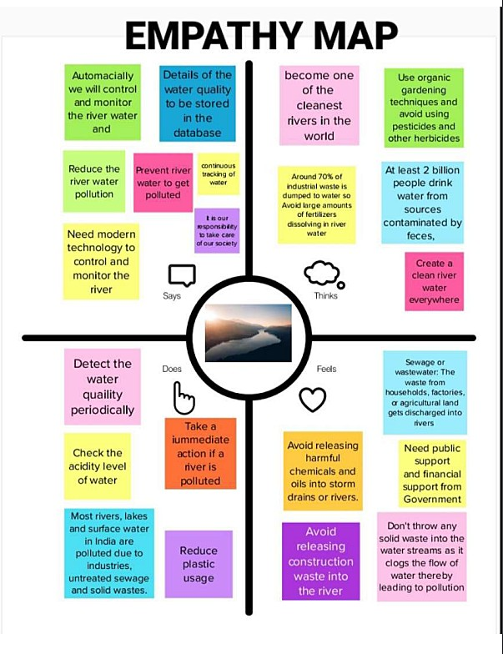

# Ideation & Brainstorming:

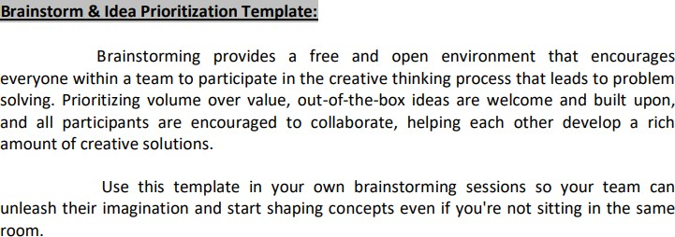

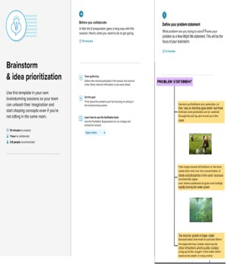

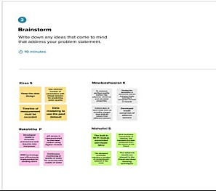

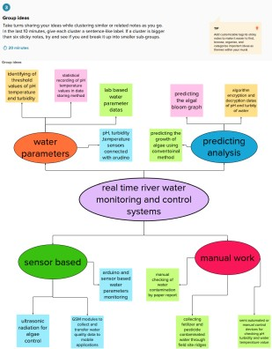

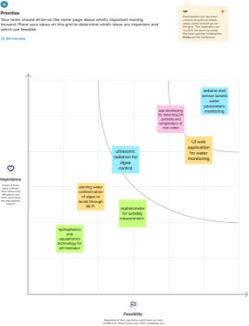

* 1. **Proposed Solution :**

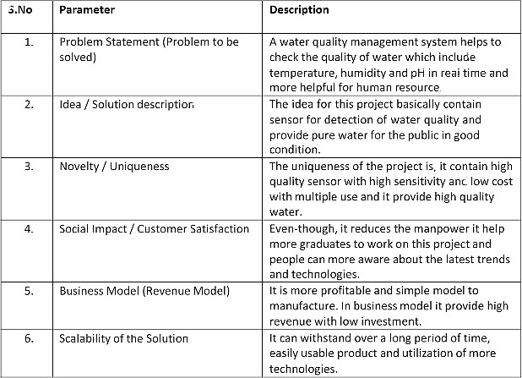

# Problem Solution ﬁt:

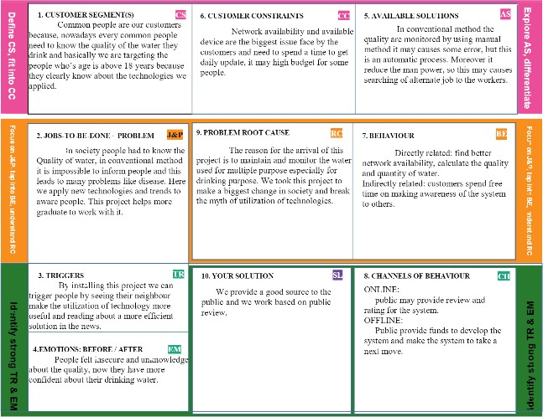

1. **REQUIREMENT ANALYSIS:**

# Functional requirement:

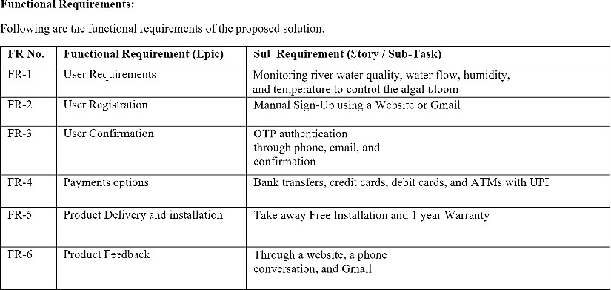

* 1. **Non-Functional requirements:**

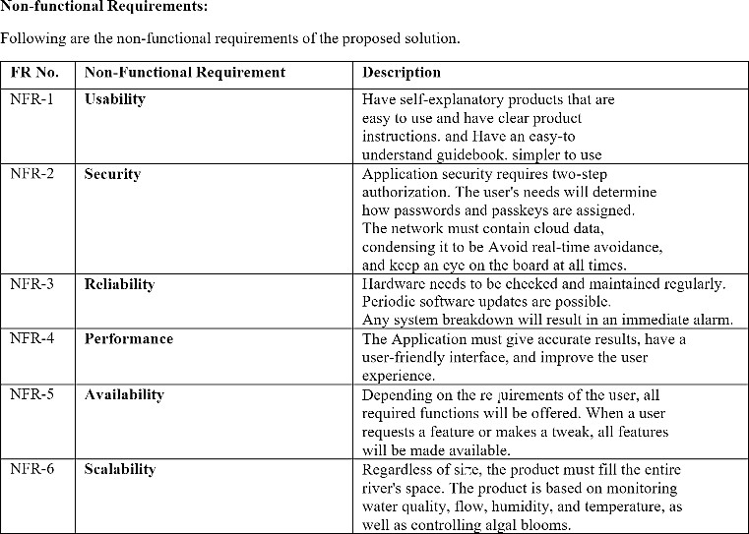

# PROJECT DESIGN:

* 1. **Data Flow Diagrams:**

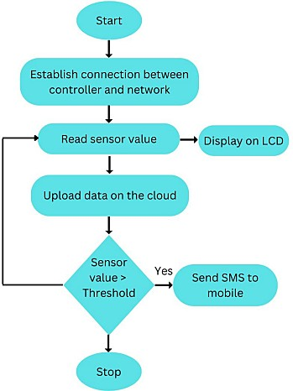

# Solution & Technical Architecture: Solution architecture:

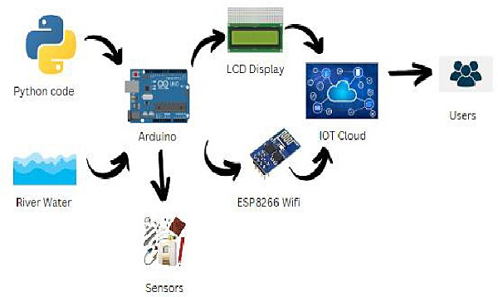

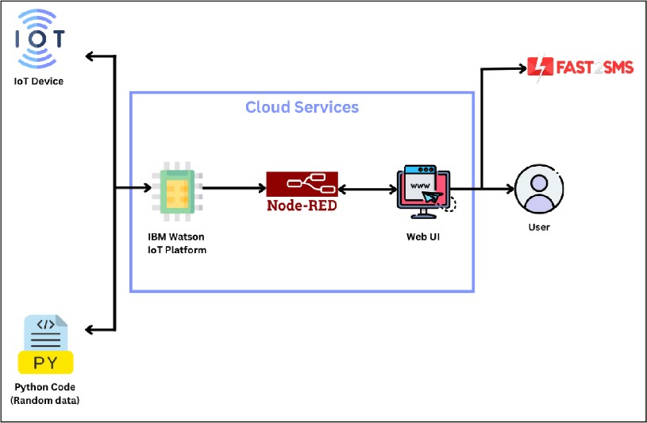**Technical architecture:**

# User Stories:

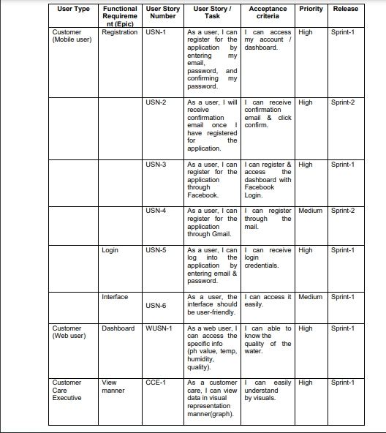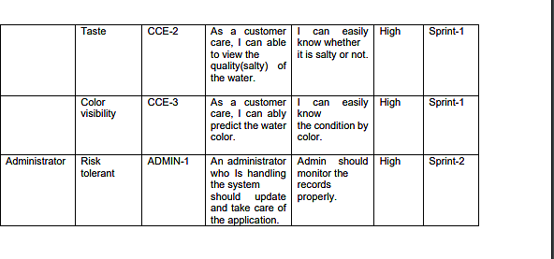

1. **PROJECT PLANNING & SCHEDULING:**

# Sprint Planning & Estimation:

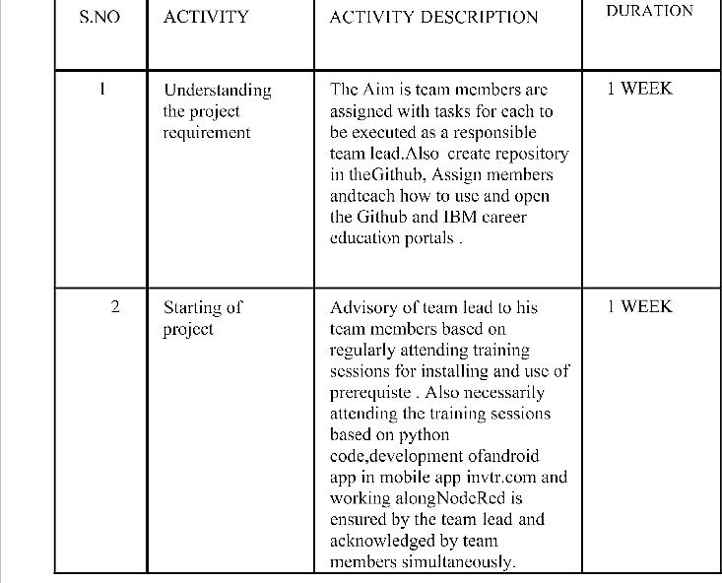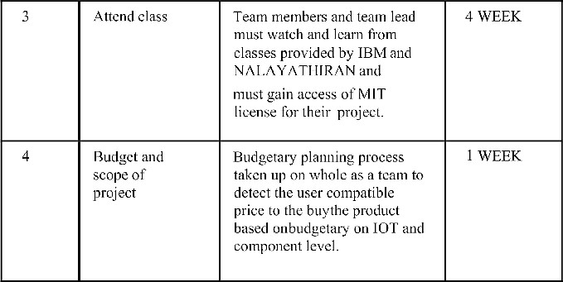

* 1. **Sprint Delivery Schedule:**

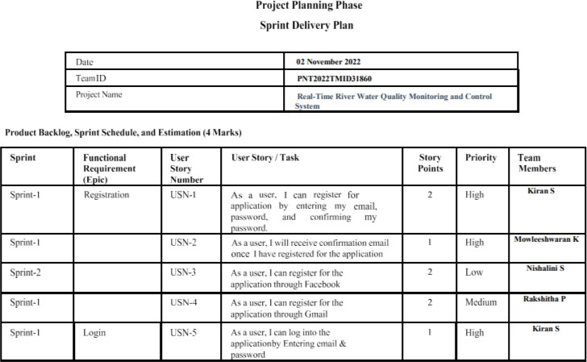

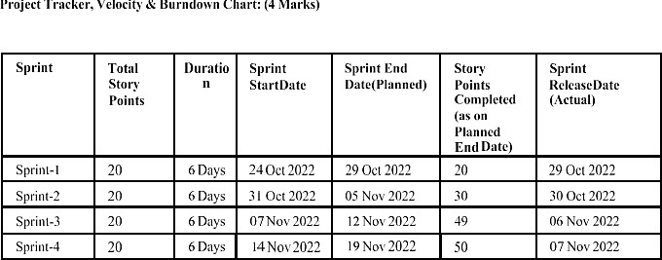

# Reports from JIRA:

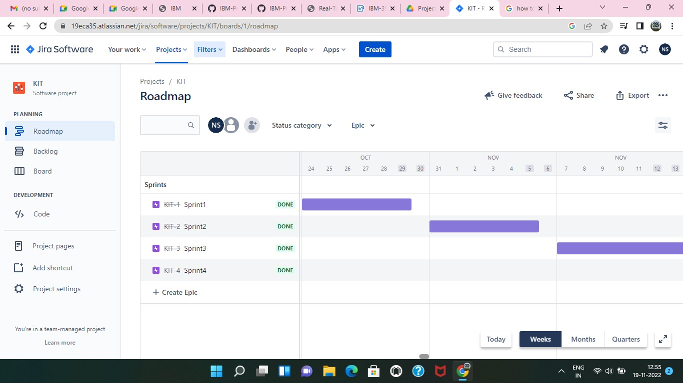

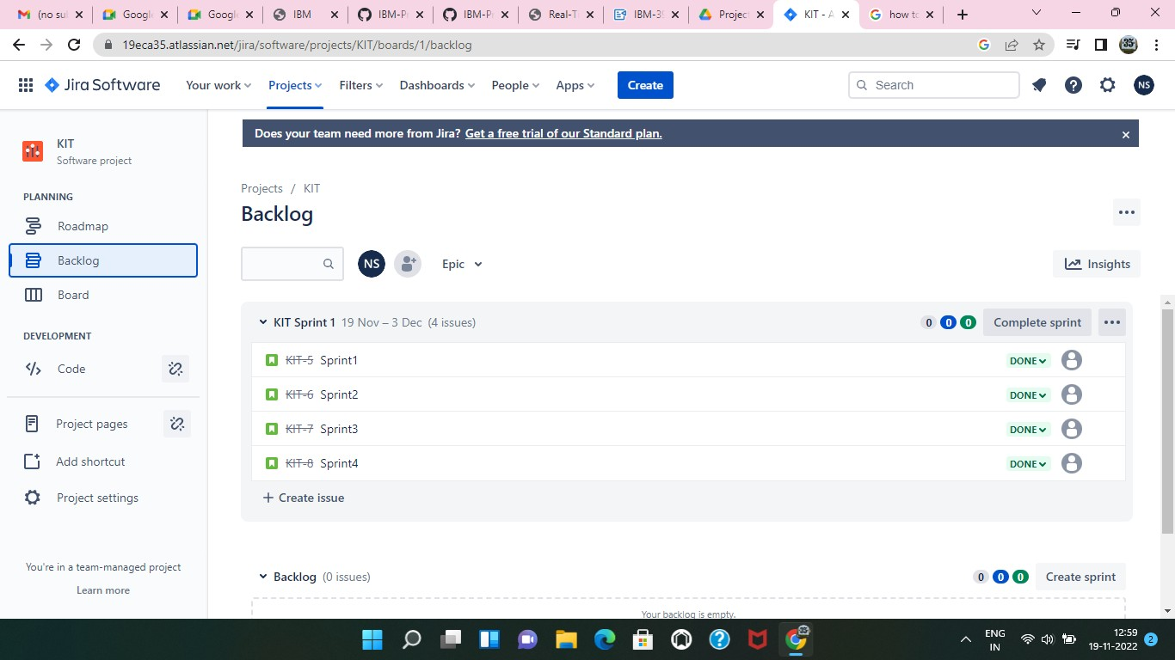

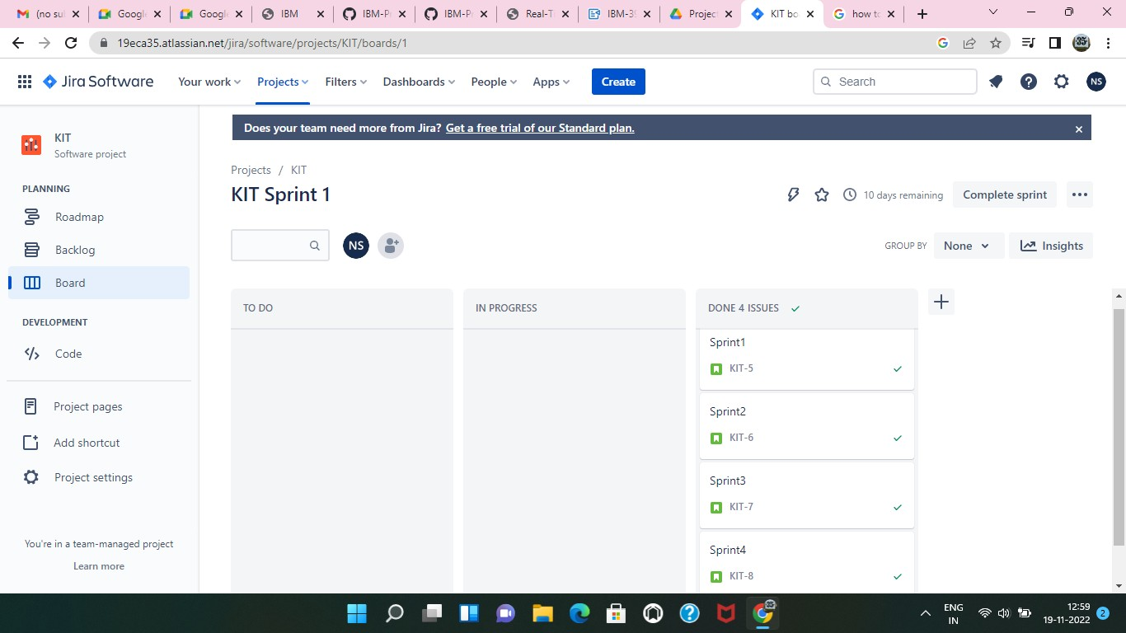

1. **CODING & SOLUTIONING:**

# Feature 1:

* IOT device
* IBM Watson platform
* Node red
* Cloudant DB
* Web UI
* Geofence MIT App
* Python code

# Feature 2:

* Registration
* Login
* Verification
* SMS
* Adding Queries

labl_0 = Label(base, text="Registration form",width=20,font=("bold", 20)) labl_0.place(x=90,y=53)

lb1= Label(base, text="Enter Name", width=10, font=("arial",12)) lb1.place(x=20, y=120) en1= Entry(base) en1.place(x=200, y=120)

lb3= Label(base, text="Enter Email", width=10, font=("arial",12)) lb3.place(x=19, y=160) en3= Entry(base) en3.place(x=200, y=160)

lb4= Label(base, text="Contact Number", width=13,font=("arial",12)) lb4.place(x=19, y=200) en4= Entry(base) en4.place(x=200, y=200)

lb5= Label(base, text="Select Gender", width=15, font=("arial",12)) lb5.place(x=5, y=240) var = IntVar()

Radiobutton(base, text="Male", padx=5,variable=var, value=1).place(x=180, y=240) Radiobutton(base, text="Female", padx =10,variable=var, value=2).place(x=240,y=240) Radiobutton(base, text="others", padx=15, variable=var, value=3).place(x=310,y=240) list_of_cntry = ("United States", "India", "Nepal", "Germany") cv = StringVar() drplist= OptionMenu(base, cv, *list_of_cntry) drplist.config(width=15) cv.set("United States") lb2= Label(base, text="Select Country", width=13,font=("arial",12)) lb2.place(x=14,y=280)

drplist.place(x=200, y=275)

lb6= Label(base, text="Enter Password", width=13,font=("arial",12)) lb6.place(x=19, y=320)

en6= Entry(base, show='*') en6.place(x=200, y=320)

lb7= Label(base, text="Re-Enter Password", width=15,font=("arial",12)) lb7.place(x=21, y=360) en7 =Entry(base, show='*') en7.place(x=200, y=360)

Button(base, text="Register", width=10).place(x=200,y=400) base.mainloop() def generateOTP() :

# Declare a digits variable

# which stores all digits digits = "0123456789" OTP = ""

# length of password can be changed

# by changing value in range for i in range(4) : OTP += digits[math.floor(random.random() * 10)] return OTP

# Driver code if name == " main " :

print("OTP of 4 digits:", generateOTP()) digits="0123456789" OTP=""

for i in range(6):

OTP+=digits[math.floor(random.random()*10)]

otp = OTP + " is your OTP" msg= otp s = smtplib.SMTP('smtp.gmail.com', 587) s.starttls() s.login("Your Gmail Account", "You app password")

emailid = input("Enter your email: ") s.sendmail('&&&&&&&&&&&',emailid,msg) a = input("Enter Your OTP >>: ")

if a == OTP: print("Verified")

else: print("Please Check your OTP again") roo

# TESTING:

Testing is more important in every project because we need to know the performance such that the value of product is depend up on the performance .

# Test Cases:

1.Controlling of app from the phone 2.Time complexity of data flow.

3.Peformance

4.Data from node to UI and to user.

# User Acceptance Testing:

Most of our development is done through the IBM platforms so that the sensors suggested that no need of particular testing. But user performance is well and good.

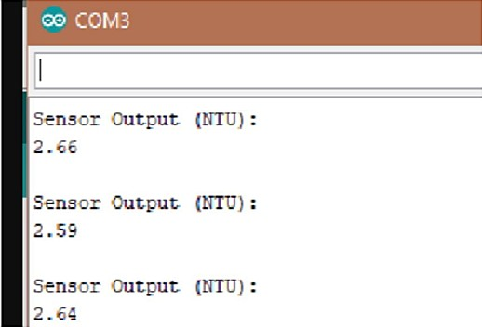

# RESULTS:

We are displaying the resulting sensed pH, temp, turbidity, and ORP values. It continuously senses the values of pH, temp, turbidity, and ORP and the resulting values are displayed to the LCD, PC or mobile in real-time. If the acquired value is above the threshold value comments will be displayed as ‘BAD’. If the acquired value is lower than the threshold value comments will be displayed as ‘GOOD’. A bar/line graph will also be shown for perfect understanding. The time series representation of sensor data with decision the resulting sensed pH, temp, turbidity, and ORP values. It continuously senses the values of pH, temp, turbidity, and ORP and the resulting values are displayed to the LCD, PC or mobile in real-time. If the acquired value is above the comments will be displayed as ‘GOOD’. A bar/line graph will also be shown for perfect understanding. Most of our development is done through the IBM platforms so that the sensors suggested that no need of particular testing. But user performance is well and good.

# ADVANTAGES & DISADVANTAGES:

**Advantages:**

The benefits of advancing to a real-time water quality monitoring system are many but include as the most important access to instantaneous data,ease and convenience of use and improved accuracy of water quality measurements.

# Disadvantages:

The lab testing and analysis takes some time and hence the lab results does not reflect real time water quality measurement due to delay in measurement.This process is time consuming due to slow process of manual data.

# CONCLUSION:

Compared to the previous related works, the cost of the system prototype is considerably low. To ensure the portability of the device, a self-made, small size Arduino microcontroller is used. The developed system was tested under different conditions, with solution of water with different impurities, and in different periods of time.To test more parameters of the water quality for some applications, other sensors can be included in the system. The system has wide application and it is usable and affordable by all categories of users.

# FUTURE SCOPE:

The capability of water quality monitoring system can be enhanced to obtain more efficient reliable results. The number of parameters to be sensed can be increased by the addition of multiple sensors to measure dissolved oxygen (DO), chemical oxygen demand (COD), biochemical oxygen demand (BOD), ammonia nitrogen, nitrate, nitrite, phosphate. The system can be further upgraded using wireless sensor networks. The system can be expanded to monitor hydrologic, air pollution, industrial and agricultural production and so on. It has widespread application and extension value. Work can be carried on to include controlling the supply of water.

# APPENDIX:

**source code:**

<**html**>

<**head**>

<**meta** charset="UTF-8">

<**title**> Login </**title**>

<**link** rel="stylesheet" href="{{ url_for('static', filename='style.css') }}">

</**head**>

<**body**></**br**></**br**></**br**></**br**></**br**>

<**div** align="center">

<**div** align="center" class="border">

<**div** class="header">

<**h1** class="word">Login</**h1**>

</**div**></**br**></**br**></**br**> <**h2** class="word">

<**form** action="{{ url_for('login') }}"

method="post"> <**div** class="msg">{{ msg

}}</**div**><**input** id="username"name="username"

type="text" placeholder="Enter Your Username" class="textbox"/></**br**></**br**>

<**input** id="password" name="password" type="password" placeholder="Enter Your Password" class="textbox"/></**br**></**br**></**br**>

<**input** type="submit" class="btn" value="Sign In"></**br**></**br**>

</**form**>

</**h2**>

<**p** class="bottom">Don't have an account? <**a** class="bottom" href="{{url_for('register')}}"> Sign Up here</**a**></**p**>

</**div**>

</**div**>

</**body**>

</**html**>

## Register.html

<**html**>

<**head**>

<**meta** charset="UTF-8">

<**title**> Register </**title**>

<**link** rel="stylesheet" href="{{ url_for('static', filename='style.css') }}">

</**head**>

<**body**></**br**></**br**></**br**></**br**></**br**>

<**div** align="center">

<**div** align="center" class="border">

<**div** class="header">

<**h1** class="word">Register</**h1**>

</**div**></**br**></**br**></**br**> <**h2** class="word">

<**form** action="{{ url_for('register') }}"

method="post"> <**div** class="msg">{{ msg }}</**div**>

<**input** id="username" name="username" type="text" placeholder="Enter Your Username" class="textbox"/></**br**></**br**>

<**input** id="password" name="password" type="password" placeholder="Enter Your Password" class="textbox"/></**br**></**br**>

<**input** id="email" name="email" type="text"

placeholder="Enter Your Email ID" class="textbox"/></**br**></**br**>

<**input** type="submit" class="btn" value="Sign

Up"></**br**> </**form**>

</**h2**>

<**p** class="bottom">Already have an account? <**a** class="bottom" href="{{url_for('login')}}"> Sign In here</**a**></**p**> </**div**>

</**div**>

</**body**>

</**html**>

## Style.css

.header{ **padding**: 5px 120px; **width**: 150px;

## height:

70px; **background-color**: #236B8E;

}

.border{ **padding**: 80px 50px; **width**: 400px; **height**:

450px;

**border**: 1px solid #236B8E; border-radius: 0px;

**background-color**: #9AC0CD;

}

.btn {

**padding**: 10px 40px; **background-color**: #236B8E; **color**: #FFFFFF;

**font-style**: oblique; **font-weight**: bold; border-radius: 10px;

}

.textbox{ **padding**: 10px 40px; **background- color**: #236B8E; text-**color**: #FFFFFF; border-radius: 10px;

}

::placeholder { **color**:

#FFFFFF; opacity: 1; **font- style**: oblique; **font-weight**: bold;

}

.word{ **color**: #FFFFFF; **font-style**: oblique; **font-weight**: bold;

}

.bottom{ **color**: #236B8E; **font- style**: oblique; **font-weight**: bold;

}

# GitHub & Project Demo Link

**:**[https://drive.google.com/ﬁle/d/1ScZSqeQuPWz7o4RgRQFVsK9f9zjo6qzk/view?usp=drivesdk](https://drive.google.com/file/d/1ScZSqeQuPWz7o4RgRQFVsK9f9zjo6qzk/view?usp=drivesdk)